*Document Overview:* Through a station-based lab activity, students will get a better understanding of reaction versus reflex. They will subject their body to several tests to collect and analyze data about their personal responses. The ideas of homeostasis and evolutionary advantage are highlighted. This could be an introduction to the nervous system, specifically the brain.

*Minnesota State Academic Science Standards:*

|  |  |
| --- | --- |
| 9.1.1.1.2 | Understand that scientists conduct investigations for a variety of reasons, including: to discover new aspects of the natural world, to explain observed phenomena, to test the conclusions of prior investigations, or to test the predictions of current theories. |
| 9.1.1.2.1 | Formulate a testable hypothesis, design and conduct an experiment to test the hypothesis, analyze the data, consider alternative explanations and draw conclusions supported by evidence from the investigation. |
| 9.1.3.1.3 | Describe how positive and/or negative feedback occur in systems. For example: The greenhouse effect. |
| 9.1.3.4.2 | Determine and use appropriate safety procedures, tools, computers and measurement instruments in science and engineering contexts. For example: Consideration of chemical and biological hazards in the lab. |

*Next Generation Science Standards*

|  |  |
| --- | --- |
| HS-LS1-2. | Develop and use a model to illustrate the hierarchical organization of interacting systems that provide specific functions within multicellular organisms. [Clarification Statement: Emphasis is on functions at the organism system level such as nutrient uptake, water delivery, and organism movement in response to neural stimuli. An example of an interacting system could be an artery depending on the proper function of elastic tissue and smooth muscle to regulate and deliver the proper amount of blood within the circulatory system.] [*Assessment Boundary: Assessment does not include interactions and functions at the molecular or chemical reaction level.*] |
| HS-LS1-*3*. | Plan and conduct an investigation to provide evidence that feedback mechanisms maintain homeostasis.[Clarification Statement: Examples of investigations could include heart rate response to exercise, stomate response to moisture and temperature, and root development in response to water levels.] [Assessment Boundary: Assessment does not include the cellular processes involved in the feedback mechanism.] |

*Objective:* Students will

* Understand how reflexes work.
* Understand the difference between a reflex and a reaction
* Demonstrate some human reflexes
* Be able to calculate reaction time

*Type of Activity:* wet lab

*Duration:* 90-minute to do the activities, more time to finish the questions

*Connection to Nobel speakers:* This activity is designed to go with António Damásio’s presentation as his research is in the field of neuroscience.

# *Teacher Tips:* Set this up as a station lab. If you do not have calipers, paper clips will also work. This is set up to be done with the use of an Ipad, but it can be done without.

# *Concepts and key words:* Reflexes, reactions, brain activity, response to stimuli

# *Description of Activity:* Students work on several stations where they test their body’s reaction to certain stimuli: touch, temperature, sound, light, etc. They collect quantitative and qualitative data.

# *Materials:* calipers, meter stick, containers big enough to fit a hand into (3), flashlights, reflex hammers

*Activity: (see below)*

Name___________________________________________

Partner name________________________________________

**Observing Nervous Responses**

**Background**

The nervous system is composed of different conductive tissues that carry impulses to all parts of the body and is also responsible for the body’s responses. For example, your nervous system initiates many types of reflex actions. When you touch a hot object, you immediately pull your hand away. You might be aware of this reflex action occurring, but you are unable to stop or control it.

**How do reflex actions occur**? When your hand touches a hot object, heat receptors in the skin send an impulse to the muscles of the arm to contract. The impulse travels along the sensory neurons, through interneurons in the spinal cord. The impulse leaves the spinal cord, and travels through motor neurons to the arm muscles, causing them to contract and pull your hand away. This pathway is called the **reflex arc**. Because the reflex arc involves only the spinal cord and not the brain, a reflex action occurs in a matter of a fraction of a second, you are not able to control a reflex – it happens automatically.

**In a nonreflex response**, an impulse must travel to the brain. The impulse takes the same path as in a reflex action but also goes to the brain. The brain interprets the stimulus and initiates an appropriate response. In this case, the time it takes to respond is measurably longer than the time required for a reflex arc. A person’s reaction time can be measure by how quickly he or she can perceive a stimulus and then react to it. Driving a car, playing hockey or hunting are examples of activities in which reaction time is very important.

**Draw a picture demonstrating the reflex arc.**

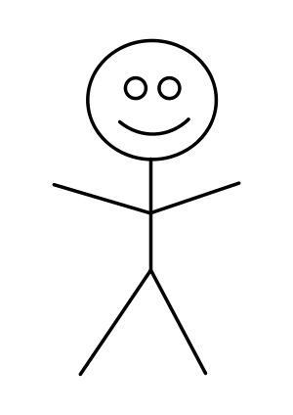Include and label 1) sensory neuron 2) interneurons 3) spinal cord 4) brain 5) motor neuron

**Draw a picture demonstrating a nonreflex response.**

Include and label 1) sensory neuron 2) interneurons 3) spinal cord 4) brain 5) motor neuron

**Procedure**

**Part 1. Knee Reflex**

1. Sit on the lab table.
2. Make sure your leg is loose and relaxed.
3. Have you lab partner tap your knee firmly, slightly below the knee cap.
4. Record your observations.
5. Repeat steps 1-3. This time try to stop your knee from jerking. Record your observations
6. Switch roles and repeat.

Initial Observations:

Observations when trying to stop the reflex:

Google search ‘Causes of no knee-jerk reflex’ and list 3 medical conditions that would have no knee jerk reflex as a symptom

1.

2.

3.

**Part 2. Pupillary Reflex**

1. Close one eye and cover it with your hand. Keep your other eye open.
2. Have your partner shine a light close to your open eye for about 20 seconds. **CAUTION:** *Do not shine the light directly into the eye.*
3. Quickly remove your hand from the other (closed) eye.
4. Observe what happens to the pupils of both the eye exposed to light and the eye that remained in darkness.
5. Record results below.
6. Switch roles and repeat.

**Data Table 1**

|  |  |
| --- | --- |
| Trial | Stimulus Observations |
| Eye exposed to Light | Describe what you noticed about the pupil of the open eye when the covered eye was opened. |
| Eye exposed to Darkness | Describe what you noticed about the pupil of the closed eye when it was uncovered. |

**Part 3. Reaction Time**

1. Rest your elbow on a table and extend your arm over its side as shown in figure 2.
2. Have your partner hold a meter stick in the air, with the 0-cm line between the thumb and index finger with your extended hand.
3. Have your partner drop the meter stick, without advance notice. Try and catch the meter stick.
4. Record in centimeters the position of your thumb and index finger.
5. Make sure each partner records their own reaction time.

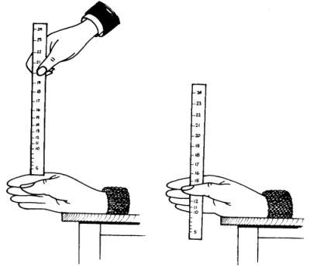

|  |  |
| --- | --- |
| Trial | Distance (cm) |
| 1 |  |
| 2 |  |
| 3 |  |
| 4 |  |

**Data Table 2**

**Part 4. Heat sensation**

1. Place one hand in hot water and one in ice water for 60 seconds.
2. Remove both hands and place them both into room temperature water.
3. Record the observations and sensations that each hand has below
4. Repeat for second group member.

Observations:

Describe how the skin of the hand in the hot water looked after 60 seconds. What would be a reason for this? (what is your body doing to attempt to maintain homeostasis?)

Describe how the skin of the hand in the cold water looked after 60 seconds. What would be a reason for this? (what is your body doing to attempt to maintain homeostasis?)

Describe the sensations for each hand when they were placed in the room temperature water.

Research and list 3 things that the body does in response to a hypothermic situation.

**Part 5. Speed of Reaction-Reflexes App-(IPad App)** 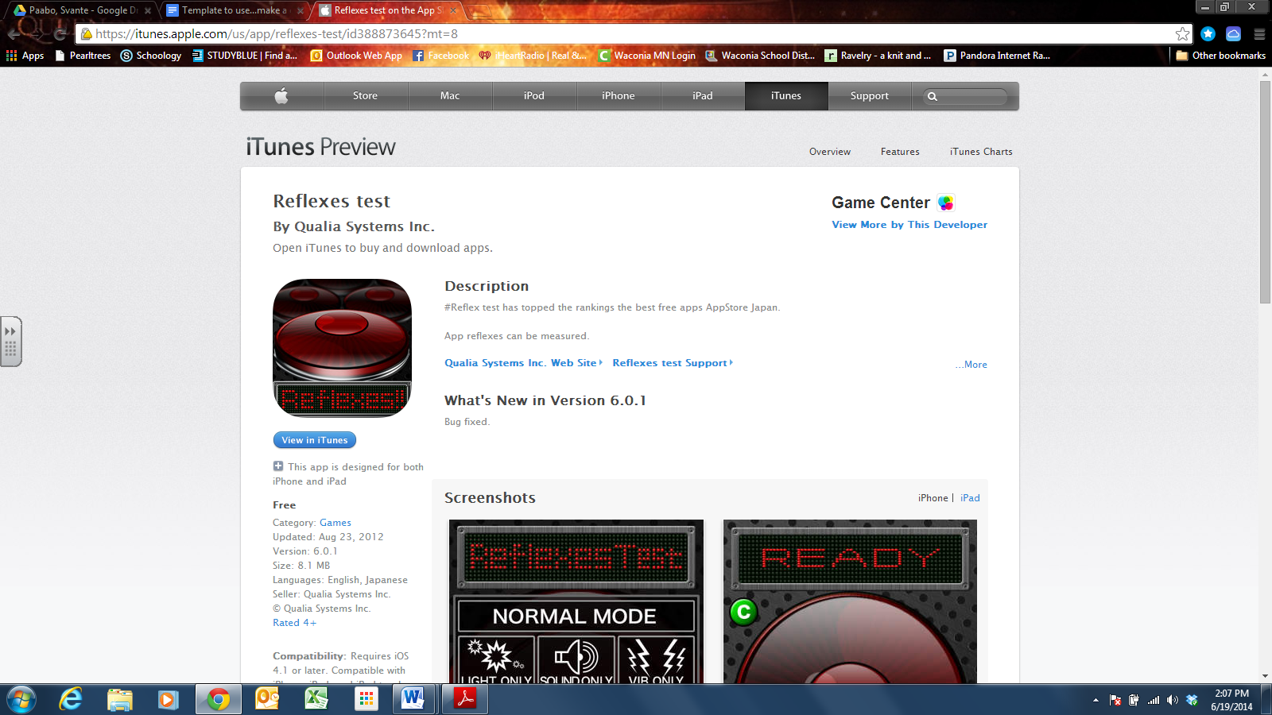

1. Open the ‘Reflexes’ App
2. Choose the following setting: Normal Mode
3. To do this level, you press and hold the ‘Push button’, when it says “Start”, you remove your finger and press the button again as fast as you can.
4. Record three timings below

___________________ _____________________ ____________________

Average:__________________

1. What two variables could you test on this mode?

_________________________ ____________________

1. Go back to the home page for the app
2. Choose ‘9 buttons’ setting and play for 3 rounds, recording your timing below.

___________________ _____________________ ______________________

Average:____________________

1. Play against your partner for three rounds and record who the amazing winner is below with their time

Winner round 1___________time___________

Winner round 2_______________time___________

Winner round 3_____________ time_____________

**Part 5. Pressure sensation**

1. Open the caliper very little
2. Have one partner close their eyes.
3. Place either one or two caliper tips on their index fingers
4. Record if the person properly identifies the number of tips touching their finger tip
5. Repeat steps 1-3 three times and record the data
6. Repeat steps 1-4 for the back of the neck, top of the arm and lips
7. Choose one area that was the most sensitive and see how close the tips need to be for them to only feel one point. Start with the calipers open wider and make them closer until the partner can only feel one tip, even though there are two being used.

**Index finger**

|  |  |  |  |
| --- | --- | --- | --- |
| Trial Number | Number of Tips used | Number Identified | Right or Wrong |
| 1 |  |  |  |
| 2 |  |  |  |
| 3 |  |  |  |
| 4 |  |  |  |

**Back of Neck**

|  |  |  |  |
| --- | --- | --- | --- |
| Trial Number | Number of Tips used | Number Identified | Right or Wrong |
| 1 |  |  |  |
| 2 |  |  |  |
| 3 |  |  |  |
| 4 |  |  |  |

**Top of Arm**

|  |  |  |  |
| --- | --- | --- | --- |
| Trial Number | Number of Tips used | Number Identified | Right or Wrong |
| 1 |  |  |  |
| 2 |  |  |  |
| 3 |  |  |  |
| 4 |  |  |  |

**Lips**

|  |  |  |  |
| --- | --- | --- | --- |
| Trial Number | Number of Tips used | Number Identified | Right or Wrong |
| 1 |  |  |  |
| 2 |  |  |  |
| 3 |  |  |  |
| 4 |  |  |  |

**Area chosen (finger, neck, arm or lips) _________ How close were the tips when the person was unable to tell that there were 2 pressure points? ________________**

**Part 6: Increasing your brain power** 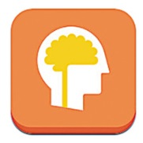

1. Open the app Lumosity.
2. Set up an account, choosing what you want to work on.
3. Once you are set up, choose ‘Begin Your Workout’.
4. Play until the app says you are done for the day.
5. Then go back to the home screen and choose “Your brain” at the bottom of the page. Screen shot the image of your results and paste that information below or print it off.

**Part 7: Concept Map Creation**

**Using the outline below, create a concept map using the app IdeaSketch+. Make a screen shot of your finished map and paste it in the space below. You can cover the outline if you need to for space**

**The Nervous System**

1. **Central Nervous System**
   1. **Control**
   2. **Brain and Spinal Cord**
2. **Peripheral Nervous System**
   1. **Gathers and sends messages**
   2. **Nerves and Sense organs**
   3. **Divisions**
      1. **Sensory**
         1. **Senses to the CNS**
      2. **Motor** 
         1. **CNS back to the muscles for movement**
         2. **Somatic division**
            1. **You are in control**
         3. **Autonomic division**
            1. **Involuntary**

**Sympathetic**

**Fight or flight response**

**Adrenaline is released, heart rate increases**

**Parasympathetic**

**Rest and Digest**

**Calms body down to normal**

**Analysis and Conclusions**

1. What happened to your knee when it was tapped? Describe the reason it does that (Google search the knee jerk response, explain the physiology of the response)
2. How does the patellar reflex protect us?
3. Could you prevent the knee jerk or pupil contraction? Explain your answer.
4. How does the pupillary response prevent injury? What would happen without it?
5. Is catching the meter stick a voluntary reaction or a reflex? Explain your answer.
6. What was the average distance the meter stick fell in your trials?
7. Name three occupations where having a fast reaction time is important.
8. In which of the 4 skin areas you were tested on were you able to correctly identify the most pressure sensation? Explain why these areas are more sensitive compared to other areas. Is there an evolutionary advantage to that?

Area________________ Explanation:

1. Suggest some possible ways (plural) that reflex arcs could be advantageous to a species.
2. Google search “Brain plasticity”. Do some reading, and then explain what it is and what that means for a student.
3. Feel free to challenge someone else to the reflex game.

*Extension and Follow-up Activity:*

To demonstrate how distraction affect reactions but not reflexes, have students repeat activities 2 and 3 with a distractor such as music or noise or a conversation with a peer. Have students compare and contrast the effects on reflexes and reactions and come up with an explanation of the differences they observed.

*Source: Waconia High School Science Department*